Unit 8 FLS

Daniel Byrne

10/22/2019

## Texas Gas Price

plotts.sample.wge(tgp$Price)

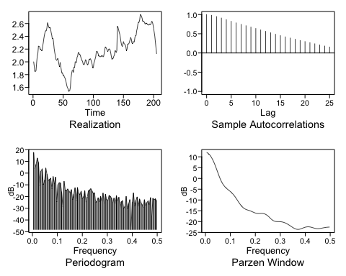

## $autplt  
## [1] 1.0000000 0.9812607 0.9485558 0.9096771 0.8684132 0.8251700 0.7835162  
## [8] 0.7453261 0.7096470 0.6747143 0.6382594 0.6001387 0.5635623 0.5260189  
## [15] 0.4881868 0.4523773 0.4200285 0.3895181 0.3575383 0.3263927 0.2975097  
## [22] 0.2695047 0.2400592 0.2096427 0.1815298 0.1561659  
##   
## $freq  
## [1] 0.004878049 0.009756098 0.014634146 0.019512195 0.024390244  
## [6] 0.029268293 0.034146341 0.039024390 0.043902439 0.048780488  
## [11] 0.053658537 0.058536585 0.063414634 0.068292683 0.073170732  
## [16] 0.078048780 0.082926829 0.087804878 0.092682927 0.097560976  
## [21] 0.102439024 0.107317073 0.112195122 0.117073171 0.121951220  
## [26] 0.126829268 0.131707317 0.136585366 0.141463415 0.146341463  
## [31] 0.151219512 0.156097561 0.160975610 0.165853659 0.170731707  
## [36] 0.175609756 0.180487805 0.185365854 0.190243902 0.195121951  
## [41] 0.200000000 0.204878049 0.209756098 0.214634146 0.219512195  
## [46] 0.224390244 0.229268293 0.234146341 0.239024390 0.243902439  
## [51] 0.248780488 0.253658537 0.258536585 0.263414634 0.268292683  
## [56] 0.273170732 0.278048780 0.282926829 0.287804878 0.292682927  
## [61] 0.297560976 0.302439024 0.307317073 0.312195122 0.317073171  
## [66] 0.321951220 0.326829268 0.331707317 0.336585366 0.341463415  
## [71] 0.346341463 0.351219512 0.356097561 0.360975610 0.365853659  
## [76] 0.370731707 0.375609756 0.380487805 0.385365854 0.390243902  
## [81] 0.395121951 0.400000000 0.404878049 0.409756098 0.414634146  
## [86] 0.419512195 0.424390244 0.429268293 0.434146341 0.439024390  
## [91] 0.443902439 0.448780488 0.453658537 0.458536585 0.463414634  
## [96] 0.468292683 0.473170732 0.478048780 0.482926829 0.487804878  
## [101] 0.492682927 0.497560976  
##   
## $db  
## [1] 17.566940 4.009325 7.188946 12.746208 8.883412 -10.223882  
## [7] 1.581017 3.549543 -9.850097 -6.142580 4.234302 -1.183031  
## [13] -6.050130 -5.526410 -4.410911 -13.240418 -3.032503 -9.059309  
## [19] -3.527006 -24.494885 -10.011928 -8.271942 -8.571692 -16.109610  
## [25] -28.942955 -7.135781 -14.554875 -14.900190 -13.584002 -15.331810  
## [31] -16.825441 -14.162481 -22.638600 -18.209851 -12.603664 -23.114363  
## [37] -12.394691 -16.834247 -18.319886 -15.486861 -21.750883 -20.253216  
## [43] -15.111825 -24.682694 -20.645936 -15.272142 -14.375676 -13.414715  
## [49] -15.447808 -17.340905 -16.931454 -25.000164 -23.976693 -21.146604  
## [55] -24.384333 -19.934197 -23.749765 -17.109483 -25.541915 -18.117652  
## [61] -22.684772 -23.499317 -19.169605 -19.929922 -21.419889 -25.358870  
## [67] -21.357535 -25.644778 -19.317870 -23.600902 -20.742243 -29.707728  
## [73] -24.521847 -23.632981 -30.138371 -28.417831 -20.001551 -30.615738  
## [79] -26.331747 -22.740741 -48.040776 -24.915168 -17.015102 -28.218282  
## [85] -23.347030 -20.499910 -28.102092 -22.156338 -24.767085 -26.884292  
## [91] -29.332198 -22.768786 -27.715014 -25.285895 -23.749266 -27.102895  
## [97] -21.029693 -36.684982 -21.598776 -22.678742 -22.030427 -23.698395  
##   
## $dbz  
## [1] 11.99518224 11.70753604 11.22806434 10.55719051 9.69668787  
## [6] 8.65123551 7.43099659 6.05561612 4.55971804 2.99864147  
## [11] 1.45007321 0.00391408 -1.26349792 -2.31774804 -3.17241512  
## [16] -3.86813979 -4.44816563 -4.94954472 -5.40709269 -5.85790489  
## [21] -6.33982450 -6.88536963 -7.51544393 -8.23540327 -9.03387046  
## [26] -9.88408863 -10.74791105 -11.58232508 -12.34714188 -13.01139208  
## [31] -13.55698129 -13.98053688 -14.29457957 -14.52659019 -14.71358053  
## [36] -14.89268982 -15.09137733 -15.32058241 -15.57230237 -15.82208400  
## [41] -16.03689417 -16.18758750 -16.26172916 -16.27005413 -16.24299034  
## [46] -16.22054329 -16.24202989 -16.33948907 -16.53462311 -16.83734764  
## [51] -17.24427203 -17.73650536 -18.27769341 -18.81521264 -19.28889370  
## [56] -19.64890816 -19.87529462 -19.98472599 -20.01874388 -20.02393841  
## [61] -20.03773045 -20.08399167 -20.17512340 -20.31609969 -20.50779019  
## [66] -20.74868198 -21.03520632 -21.36133000 -21.71804355 -22.09305451  
## [71] -22.47062834 -22.83141154 -23.15244871 -23.40835306 -23.57498174  
## [76] -23.63589296 -23.58920445 -23.45056779 -23.24976496 -23.02285444  
## [81] -22.80424865 -22.62172183 -22.49460755 -22.43389204 -22.44282389  
## [86] -22.51724873 -22.64556258 -22.80879008 -22.98176510 -23.13645309  
## [91] -23.24762440 -23.29928449 -23.28872645 -23.22577153 -23.12774413  
## [96] -23.01325567 -22.89776398 -22.79195945 -22.70231645 -22.63253404  
## [101] -22.58482682 -22.56060355

## Fitting an AR(2) to the data using MLE

mle = est.arma.wge(tgp$Price,p=2,q=0)

##   
## Coefficients of Original polynomial:   
## 1.3812 -0.4077   
##   
## Factor Roots Abs Recip System Freq   
## 1-0.9536B 1.0487 0.9536 0.0000  
## 1-0.4276B 2.3386 0.4276 0.0000  
##   
##

## Fitting an AR(2) to the data using Burg

burg = est.ar.wge(tgp$Price,p=2,type="burg")

##   
## Coefficients of Original polynomial:   
## 1.3814 -0.4058   
##   
## Factor Roots Abs Recip System Freq   
## 1-0.9575B 1.0444 0.9575 0.0000  
## 1-0.4239B 2.3592 0.4239 0.0000  
##   
##

## Forecasting using the MLE model

mlef = fore.aruma.wge(tgp$Price, phi = mle$phi, n.ahead = 24, lastn = T, limits = T, plot = T)

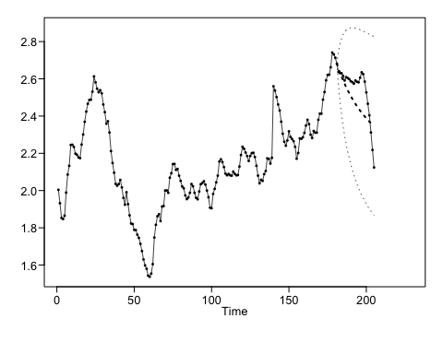

## Forecasting using the Burg Model

burgf = fore.aruma.wge(tgp$Price, phi = burg$phi, n.ahead = 24, lastn = T, limits = T, plot = T)

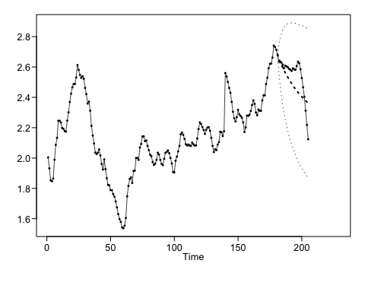

## Calculating ASE for MLE

ase = function(f,s) {  
 l = length(f) - 1  
 ls = length(s)  
 ase = mean((f - s[(ls - l):ls])^2)  
 return (ase)  
}  
  
ase(mlef$f,tgp$Price)

## [1] 0.01461187

## Calculating ASE for Burg

ase(burgf$f,tgp$Price)

## [1] 0.01309828

Neither forecast seemed particulally accurate. I wouldn’t choose either model.

## Key Takeaways

How does the AIC model estimation technique work? It might be nice to go through that math.